MADHAV INSTITUTE OF TECHNOLOGY AND SCIENCE, GWALIOR

SUBMITTED BY-

ASMITA JAIN

0901EO201017

SUBMITTED TO-

PROF. APRAJITA KUMARI

**SENSOR TECHNOLOGY LAB 220202**

**EXPERIMENT - 8**

**AIM:**

To draw the characteristic of LVDT (Linear Variable Differential Transformer).

**THEORY:**

LVDT: It is electromechanical transducer. It converts the rectilinear displacement of any object to which it is coupled mechanically in electrical signal proportional to it.

WORKING:

An alternating current is connected to the primary. It is also called as Primary Excitation. This current causes a voltage to be induced in each secondary proportional to its mutual inductance with the primary.

As the core moves, the voltages induced in the secondary's changes due to change in mutual inductance.

The coils are connected in series but in opposite phase, so that the output voltage is the difference between the two secondary voltages.

**Case 1:**

When no displacement is applied to the core and the core remains in the **null position**, the voltage induced in both the secondary windings is equal which results in net output is equal to zero

i.e., **E s1 - E s2 = 0**

**Case 2:**

When displacement is applied that the core moves in **the left direction** then the voltage induced in that (left) secondary coil is greater as compared to the emf induced in the other secondary coil.

net output = **E s1-E s2**

**Case 3:**

When force is applied to core such that it moves in the **right-hand side** direction then the emf

induced in the secondary coil 2 is greater compared to the emf voltage induced in the secondary coil 1,

net output voltage = **E s2- E s1**

**CIRCUIT DIAGRAM:**

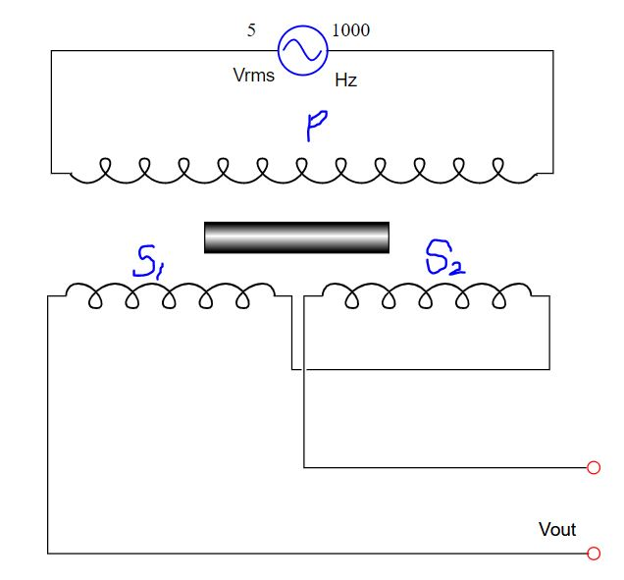

**Configurations:**

Supply voltage: 5V

No. of turns: 1000

Supply frequency: 1000 Hz

**OBERSERVATION TABLE:**

|  |  |  |  |
| --- | --- | --- | --- |
| **Displacement**  **(mm)** | **Voltage**  **(mV)** | **Displacement**  **(mm)** | **Voltage**  **(mV)** |
| 2 | 17.38 | -4 | 34.25 |
| 3 | 25.91 | -6 | 50.05 |
| 5 | 42.31 | -8 | 64.29 |
| 7 | 57.40 | -9 | 70.66 |

**GRAPH:**

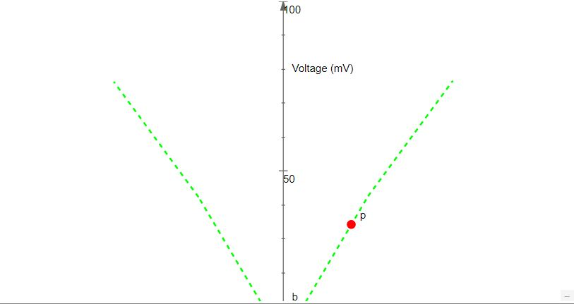

Displacement (mm)

**RESULT:**

Hence, we have studied about LVDT and drawn its characteristic.